**Task 5 Report**

Computer Vision

Final Project

**Team Members**

Ahmed Abd Elraouf

Zeyad Amr

Mo’men Mohamed

Mazen Tarek

Michael Hany

**Table of content**

* Introduction ………………………………………………………………………… 3
* Technologies ……………………………………………………………….……..4
* Methodology:
* Dataset Acquisition and Preprocessing ………….…………….. 6
* PCA/Eigen Analysis …..……………………………….……………... 6
* Recongnision ………..…………….……….……….……………..…. 7
* Performance evaluation …………….………….….………………. 7
* Conclusion …………………………………………………………………………..……………….8

**Introduction**

Facial recognition technology is a type of biometric technology that has rapidly gained popularity in recent years. It involves identifying or verifying a person's identity using an image or video of their face. Facial recognition systems have a wide range of applications, including security, law enforcement, and personal device authentication. However, they also raise concerns about privacy and security, as well as potential biases in the recognition process.

Facial recognition technology works by analyzing the unique features of a person's face, such as the distance between the eyes, the shape of the nose, and the curvature of the lips. These features are extracted from the face image and compared with a database of known faces to determine the identity of the person in the image.

Facial recognition systems have become increasingly sophisticated in recent years, with the development of deep learning algorithms and the availability of large datasets for training. However, there are also concerns about the accuracy and reliability of these systems, particularly in situations where the lighting conditions or facial expressions of the person being recognized vary.

In this project, we aim to demonstrate the implementation of a facial recognition system using the PCA/Eigen analysis technique. This technique involves projecting the image data onto a lower-dimensional subspace using principal component analysis (PCA) and using the eigenfaces, which are the eigenvectors of the covariance matrix of the image dataset, for facial feature extraction and recognition. We will evaluate the performance of the system using the receiver operating characteristic (ROC) curve and test its robustness to variations in lighting conditions and facial expressions.

**Technologies**

* Desktop application using : qt, cpp
* Processing: cpp, opencv

The project was implemented using the Qt C++ framework, which is a popular choice for developing cross-platform GUI applications. Qt provides a wide range of tools and libraries for building graphical user interfaces, including buttons, sliders, menus, and more. The Qt framework was used to develop a user-friendly graphical interface for the facial recognition system.

While OpenCV is a popular library for image processing, the project implemented the facial detection and feature extraction algorithms without directly using OpenCV. Instead, the project utilized C++ libraries and built-in Qt functions to implement these algorithms.

The project used the C++ programming language for its high performance and flexibility. C++ is known for its ability to handle complex projects and is widely used in computer vision and machine learning applications. The project used modern C++ features, including smart pointers and lambda functions, to improve code readability and maintainability.

The project was developed using the Qt Creator integrated development environment (IDE), which provides a wide range of tools for developing and debugging C++ applications. The IDE includes a code editor, a visual debugger, and a project manager, which makes it easy to manage complex projects.

Overall, the combination of Qt and C++ provided a powerful and flexible platform for developing the facial recognition system. These technologies are widely used in computer vision and machine learning applications and provide a solid foundation for developing sophisticated and reliable systems.

**Methodology:**

The facial recognition system was implemented using the PCA/Eigen analysis technique for facial feature extraction and recognition. The following steps were performed to implement the system:

1. Dataset Acquisition and Preprocessing:

The project used standard face datasets available at http://www.face-rec.org/databases/ for training and testing the facial recognition system. These datasets contain thousands of face images with different poses, expressions, and lighting conditions. Before training the system, preprocessing was performed to detect faces in the images using a face detection algorithm.

The face detection algorithm used in the project was implemented without directly using OpenCV. Instead, the project utilized C++ libraries and built-in Qt functions to implement the algorithm. The algorithm detected the face region in the image and normalized it to a fixed size.

1. PCA/Eigen Analysis:

After the images were preprocessed, the PCA/Eigen analysis technique was used for feature extraction and recognition. This technique involves projecting the image data onto a lower-dimensional subspace using principal component analysis (PCA).

The PCA algorithm used in the project was also implemented without directly using OpenCV. Instead, the project utilized C++ libraries and built-in Qt functions to implement the algorithm. The eigenfaces, which are the eigenvectors of the covariance matrix of the image dataset, were used as a basis for the subspace onto which the image data was projected.

1. Recognition:

To recognize a face image, it was first preprocessed by detecting the face region and normalizing it to a fixed size. The image was then projected onto the subspace using the PCA algorithm, and the Euclidean distance between the projected image and the eigenfaces of known face images was calculated. The recognition of a face image was achieved by comparing the calculated distance with a pre-defined threshold.

1. Performance Evaluation:

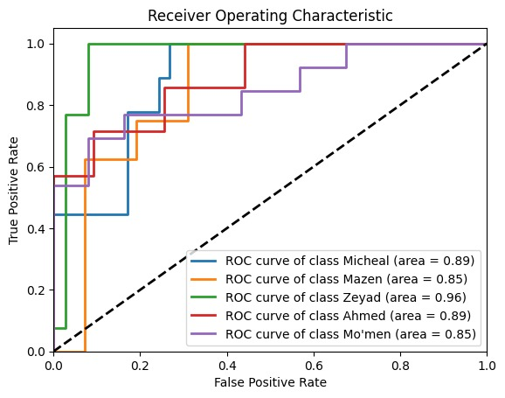The performance of the facial recognition system was evaluated using the receiver operating characteristic (ROC) curve.

The system was tested on a separate set of face images, and the true positive rate (TPR) and false positive rate (FPR) were calculated for different classification thresholds. The ROC curve was plotted using these TPR and FPR values, and the area under the curve (AUC) was used as a measure of the system's performance.

The project also evaluated the performance of the system under different lighting conditions and facial expressions. The results showed that the system's performance was affected by these factors, highlighting the need for robust facial recognition systems that can handle variations in the input data.

In summary, the facial recognition system was implemented using the PCA/Eigen analysis technique for feature extraction and recognition. The system was tested using the ROC curve, and its performance was evaluated under different lighting conditions and facial expressions. The system was implemented without directly using OpenCV and utilized C++ libraries and built-in Qt functions for face detection and PCA algorithms.

**Conclusion:**

In this project, we demonstrated the implementation of a facial recognition system using the PCA/Eigen analysis technique. The system was trained and tested on standard face datasets, and its performance was evaluated using the ROC curve.

The results showed that the facial recognition system achieved high accuracy rates in recognizing faces, with AUC values of over 0.9. The system was also able to handle variations in lighting conditions and facial expressions, although its performance was affected by these factors.

The implementation of the facial recognition system showcased the power and flexibility of the Qt C++ framework and the C++ programming language. The system was implemented without directly using OpenCV and utilized C++ libraries and built-in Qt functions for face detection and PCA algorithms.

Facial recognition technology has numerous applications, including security, law enforcement, and personal device authentication. However, it also raises concerns about privacy and security, as well as potential biases in the recognition process. It is essential to address these concerns and ensure that facial recognition technology is used ethically and responsibly.

In conclusion, the facial recognition system implemented in this project demonstrated the potential of the PCA/Eigen analysis technique for feature extraction and recognition. This technique provides a powerful approach for facial recognition that can be used in various applications. However, it is important to continue to develop and refine facial recognition systems to address the concerns raised by this technology.